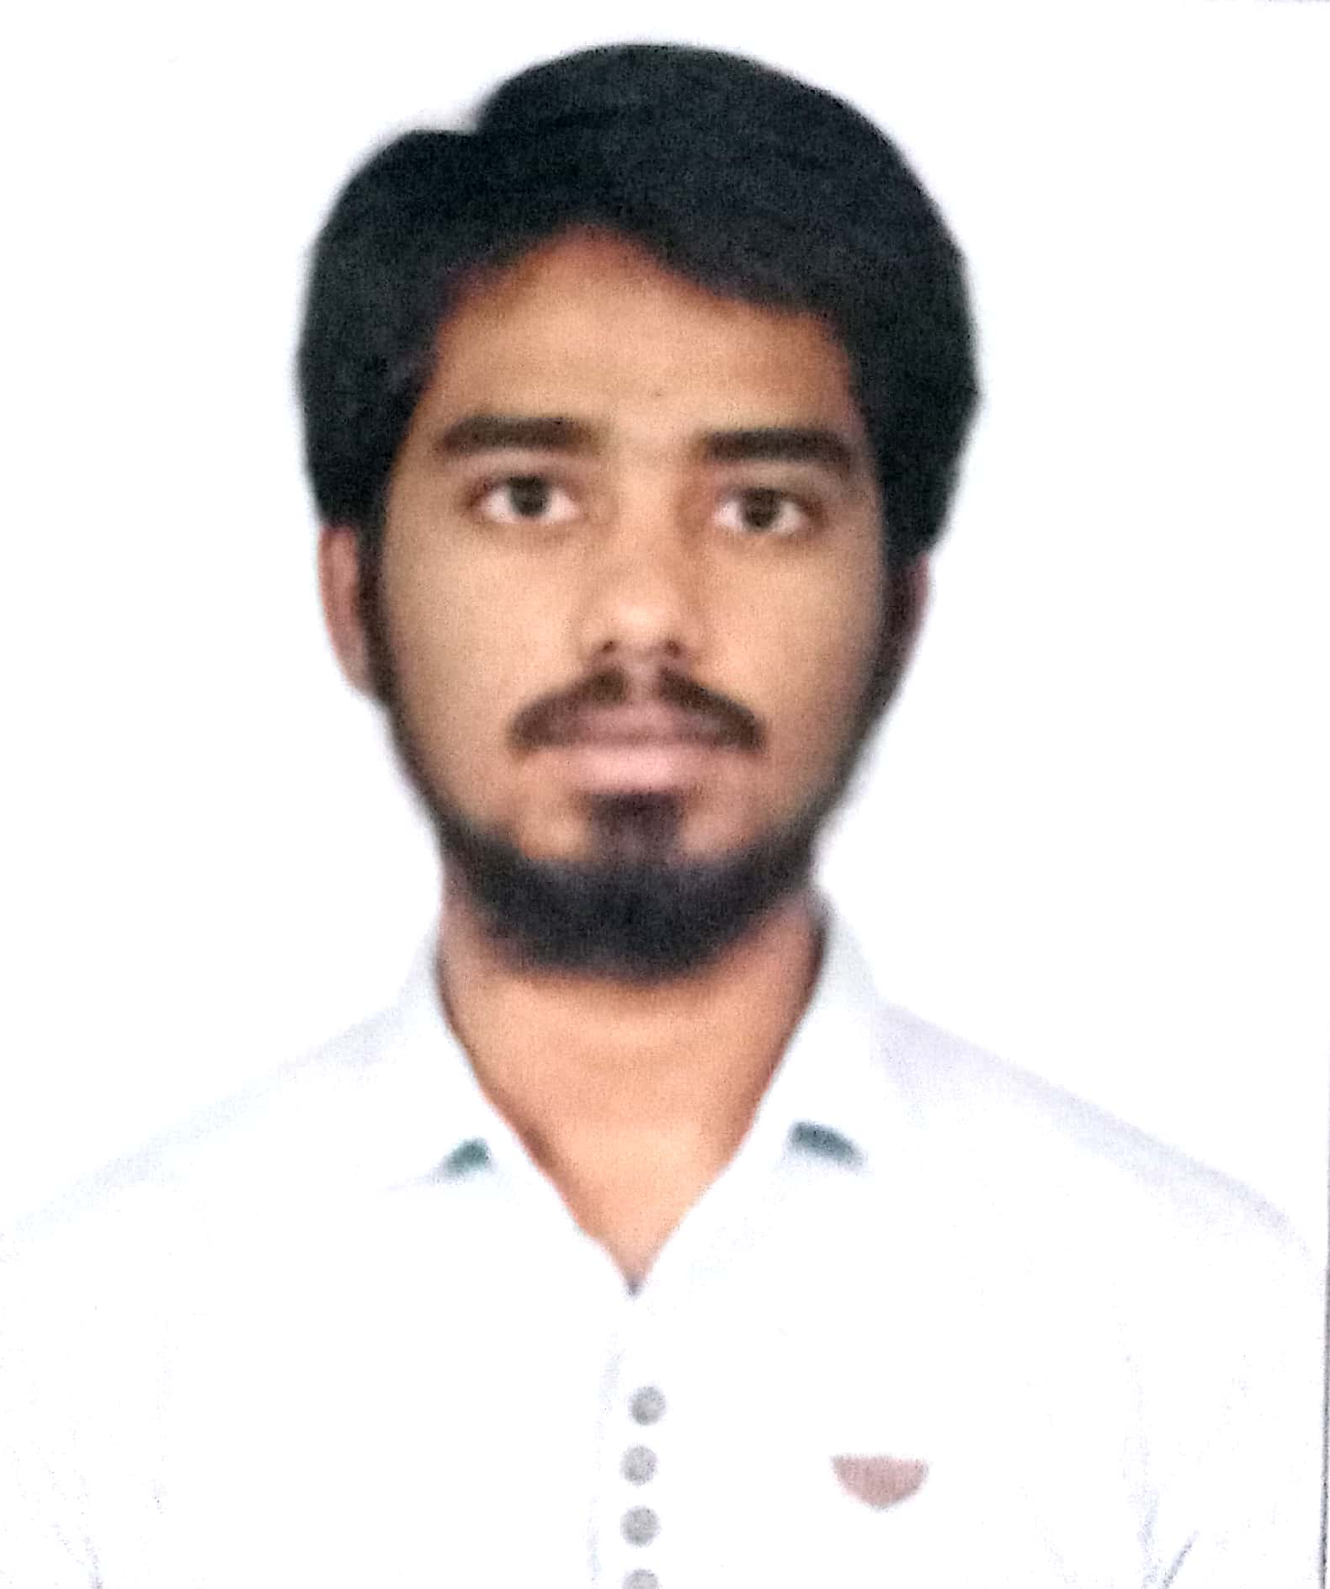 |  | chellapurAm saicharan  MECHANICAL ENGINEER
Profile  CHELLAPURAM SAICHARAN  S/O CHELLAPURAM RAGHU  M/O CHELLAPURAM RAMA  H.NO. 8-4-450  GANESH NAGAR  KARIMNAGAR  TELANGANA  INDIA  Contact  PHONE:  +91 9177324963  +91 8500402766  WEBSITE:  https://www.facebook.com/charan.chellapuram?mibextid=ZbWKwL  EMAIL:  Chellapuramcharan006@gmail.com  Hobbies  Watching tv  Playing cricket  Playing games in mobile  Reading books |  | EDUCATION  SRI VENNELA PUBLIC SCHOOL  SSC - 70 %  ALPHORES JUNIOR COLLEGE  INTER – 55 %  VAAGESWARI COLLEGE OF ENGINEERING  B.TECH ( MECH ) – 61 %  WORK EXPERIENCE  No Experience Fresher  SKILLS  MS OFFICE , MS WORD , XL  AUTO CAD  HVAC AUTOCAD  AUT

